**Unit 3A Study Guide**

1. The distance between the pitching mound and home plate is 18.45 meters. If Tim Hudson throws his fast ball at an average speed of 42.5 meters per second, how long does the batter have to see the ball before it flies past him?
2. It is 4,281 kilometers from Seattle to Hawaii. An airliner makes this journey in 4.5 hours. What was the plane’s average speed?
3. Chief Boolie, the jungle dweller, is out hunting for dinner when a coconut falls from a tree and lands on his toe. If the nut fell for 1.4 s, how fast was it travelling when it struck his toe?
4. A car is traveling at 75 km/h. 30 seconds later, the car is traveling at 75 km/h. What is the acceleration of the car?

Motion Graphs: Look at the graphs below and answer the following questions. *Pay attention to what is on the y‐axis!*

Each graph depicts the motion of a car. For each graph, or each part of a graph determine if the car is:

• moving at a constant velocity

• not moving (at rest)

• speeding up

• slowing down

5.  6.  7. 

8.  9.  10. 

Use the graph to answer the questions below:



11. During which time interval is the object moving the fastest?

12. What is the speed of the object from time 25 s to time 30 s?

13. Explain the forces acting on the objects in the situations below:

1. An space shuttle in free fall from space towards earth
2. A sky diver who has reached their terminal velocity
3. A baseball thrown towards a waiting batter

14. Label all of the forces acting in the following picture. Then draw an arrow showing the net force.

1. C:\Users\Kristin\AppData\Local\Microsoft\Windows\Temporary Internet Files\Content.IE5\XE8GZ6VB\MC900197730[1].wmf b) 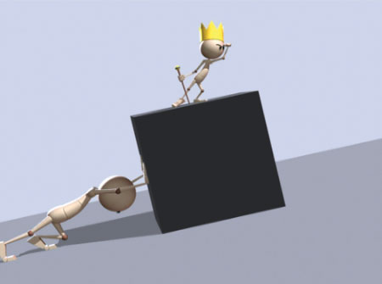

15. Give 1 reasonable solution for how friction could be reduced in figure b above.