Test is on Friday, October 21st !

Unit 3 Study Guide
States of Matter and Phase Change

- How can we describe the 4 states of matter? Complete the chart below:
 | Shape | Volume | Particle Motion (Speed and Energy) | Drawing of Particle Spacing
Solid

Liquid

Gas

Plasma

- What is the difference between and endothermic and exothermic change?

- How does matter change state?
 | Starting state ending state | Endothermic or Exothermic? | Example
Freezing

Melting

Evaporation

Condensation

Sublimation

- Be able to explain the phase change diagram below in terms of the following:
  - When is temperature increasing? Decreasing? Staying the same?
  - Where are state changes occurring?
  - Which state(s) of matter are present at each leg on the graph?
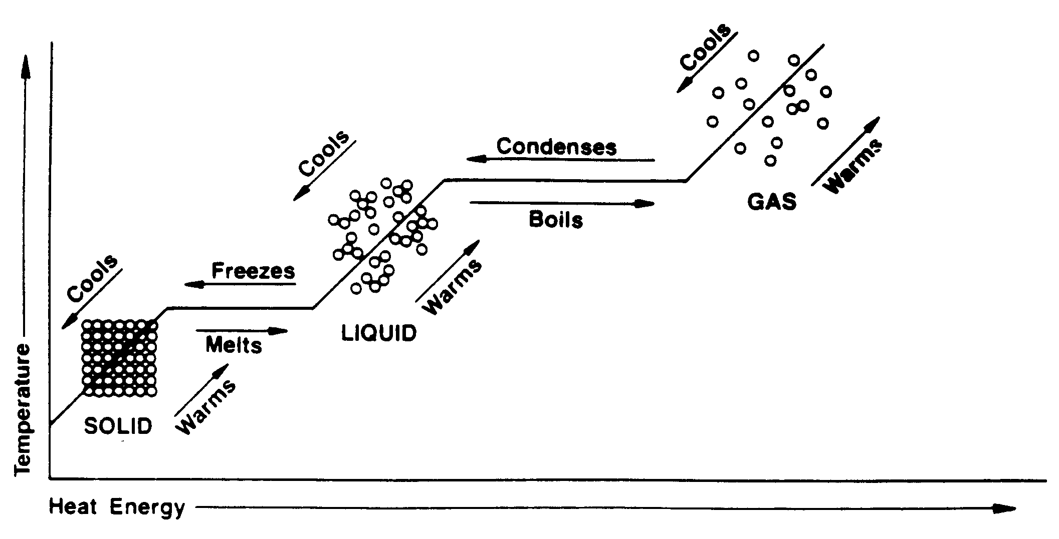

- What is The Law of Conservation of Matter/Mass? Give an example.

