Test is on Friday, October 21st !

Unit 3 Study Guide
States of Matter and Phase Change

- How can we describe the 4 states of matter? Complete the chart below:
 | Shape | Volume | Particle Motion (Speed and Energy) | Drawing of Particle Spacing
Solid | Definite; holds it shape | Definite; think V=LxWxH | Vibrations; low energy
Liquid | Indefinite; takes shape of container | Definite | Slides; greater energy than solids
Gas | Indefinite; takes shape of container | Indefinite | Random/free/excited;  Increased energy;
Plasma | Indefinite | Indefinite | Random; free movement  *Electrically Charged

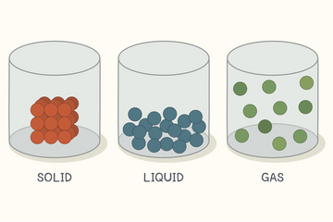
- What is the difference between and endothermic and exothermic change?

Endothermic reactions absorb heat or take in heat and the overall reaction “feels cold.” Endo = in Thermo = heat

Exothermic reactions release or give off heat and feels warm.
Exo = out Thermo = heat

- How does matter change state?
 | Starting state ending state | Endothermic or Exothermic? | Example
Freezing | Liquid >>>solid | Exothermic | Water >> ice
Melting | Solid >>> liquid | Endothermic | Ice cubes >> water
Evaporation | Liquid >>> gas | Endothermic | Surface waters of the earth evaporate into atmosphere
Condensation | Gas >>> liquid | Exothermic | Water droplets on cold windows; water droplets on a glass of ice water
Sublimation | Solid >>> gas | Endothermic | Dry ice sitting on a table at room temperature

- Be able to explain the phase change diagram below in terms of the following:
  - When is temperature increasing?
In between state changes, the section of the graph that is rising
Decreasing?
In between state changes, the section of the graph that is slanted downward (moving right to left)
Staying the same? During phase changes, the flat lines on the graph
  - Where are state changes occurring? The flat lines on the graph - Freezing point; melting point; condensation and boiling points
  - Which state(s) of matter are present at each leg on the graph? Solid and liquid while freezing/melting occurs
Liquid and gas while condensation/vaporization occurs

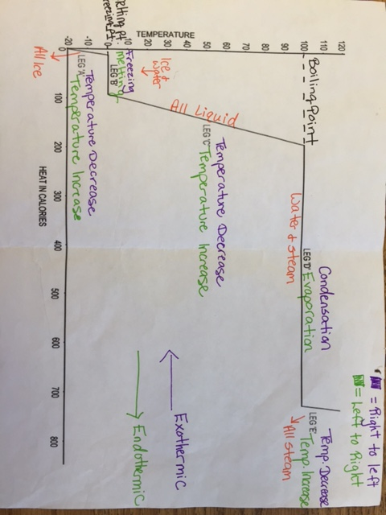

- What is The Law of Conservation of Matter/Mass? Give an example.
The Law of Conservation of Matter/Mass can neither be created nor destroyed.

EX: 5g of salt dissolved in H2O will still have 5g of salt in the water

EX: CH4 + 202 >>>>> CO2 + 2H20

Balanced chemical reactions are examples of Law of Conservation of Matter/Mass because the above balanced equation shows:
Reactants side has 1 Carbon, 4 Hydrogens, 4 Oxygens and the product side hass 1 Carbon, 4 Hydrogens, 4 Oxygens

