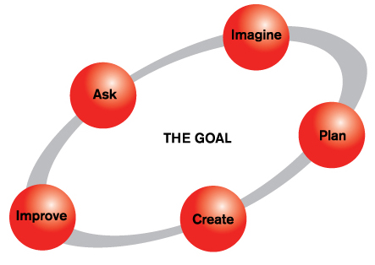
The Engineering Design Process
The Engineering Design Process is a series of steps that engineers use to guide them as they solve problems.
Many variations of the model exist. Because EiE focuses on young children, we have created a simple process that depicts fewer steps than other renditions and that uses terminology that children can understand.
While having a guide is useful for novices who are learning about engineering, it is important to note that practicing engineers do not adhere to a rigid step-by-step interpretation of the process. Rather there are as many variations of the model as there are engineers. The Engineering Design Process is cyclical and can begin at any step, or move back and forth between steps numerous times. In real life, engineers often work on just one or two steps and then pass along their work to another team.

Mistakes to avoid
- If there is no need, there is no project.
- Testing without asking the user.
- No analysis of prototype and redesign test results.
Moving through the Engineering Design Process will include the following:
Log Book Check # 1  Due: 9/19 | ASK: Identify the Purpose: What is the problem?  - Clearly define the problem you are going to solve or the situation you are going to improve.  - Express it as a goal.  - Background Research:  - What have others done?  - What constraints are there based on available resources and environment?  IMAGINE: Research possible solutions and ideas and choose the best design.  - Research design criteria  - Evaluate alternate designs  - Define a target user  - Generate questions  - Identify key words
Log Book Check #2  Due: 10/1 | Establish Design Criteria.  - Requirements that will be used to make decisions about how you build/program the product.  - Remember your target user/customer  PLAN  - Write it down, sketch it out, etc.  - Consider and explore alternatives to your approach.  - Draw a diagram of your prototype.  - Make lists of materials you will need.
Next Steps | CREATE and TEST  - Use a test plan and analyze your data. Report on results in your log book.  - Follow your plan and create it.  IMPROVE: Redesign and retest.  • Analyze Data: Modify, redesign, debug, etc. until you have achieve your design goal.  • A technical approach to your analysis is essential. Learn from your failures.  - Test it out!  SHARE – Present Your Work  - Conclusion. How did your design work. What was successful, what needs further improvement? Who should this information be shared with?  - Outline the engineering design process that you used.  - Highlight the final product, its merit, originality, and usefulness.

