**Electricity and Magnetism Review Guide**

**Vocabulary to Know:**

*Electricity*

*Electric Circuit*

*Electric Field*

*Resistor*

*Magnetism*

*Magnetic Field*

*Electromagnet*

**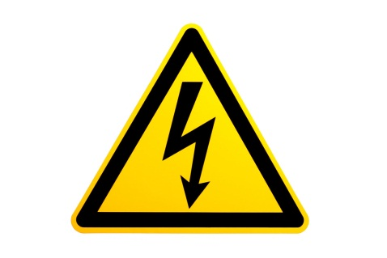***Voltage Source*

*Series Circuit*

*Parallel Circuit*

*Solenoid*

*Friction*

*Conduction*

*Induction*

**Questions to Consider:**

1. *What are the 3 methods that can be used to create electric charge?*
   1. *Friction – the “wiping away” of electrons (dragging your feet across the carpet)*
   2. *Conduction – transfer of electrons through direct contact (a shock!)*
   3. *Induction – the re-arraingment of electrons without direct contact (remember the simulation – when the balloon was close to the wall but not touching the electrons still re-arranged themselves)*
2. *What are the 3* ***main*** *parts of a circuit?*
   1. *Energy Source*
   2. *Wires*
   3. *Load*
3. *What is a switch? What does it mean if the switch is open? Closed?*
   1. *A switch can turn a circuit on and off*
      1. *An open switch means the circuit is broken and the lights are off*
      2. *A closed switch means the circuit is connected and the lights are on*
4. *What are the 2 types of circuits? Series and Parallel*
   1. *How does adding a bulb affect each of these circuits?*
      1. *Adding a bulb to a series circuit will cause the other lights in the circuit to dim because they are now splitting the current between more loads.*
      2. *If you add a bulb to a parallel circuit the bulbs will remain the same, each bulb in a parallel circuit receives the full amount of current available from the battery.*
   2. *What happens if a bulb burns out in each of these circuits?*
      1. *In a series circuit if one bulb goes out they all go out because the circuit is broken and electrons can no longer flow*
      2. *In a parallel circuit if one bulb goes out the rest will remain lit because there are other pathways for the electrons to flow along.*
5. *What is the difference between a solenoid and electromagnet?*
   1. *A solenoid is a coil of wire connected to a power source that generates a magnetic field. An electromagnet is the same thing but there is an iron core inside the coils.*
   2. *You can strengthen a solenoid or electromagnet by adding coils or increasing the size of the power source.*

**C:\Users\gould\AppData\Local\Microsoft\Windows\Temporary Internet Files\Content.IE5\8PUSX5FQ\MC900340404[1].wmf**