**Electricity and Magnetism Review Guide**

**Vocabulary to Know:**

*Electricity*

*Electric Circuit*

*Electric Field*

*Resistor*

*Magnetism*

*Magnetic Field*

*Electromagnet*

**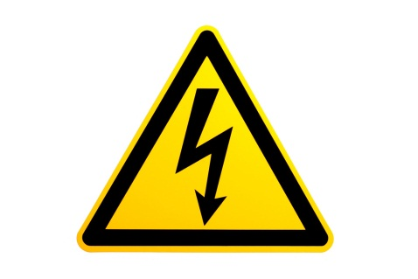***Voltage Source*

*Series Circuit*

*Parallel Circuit*

*Solenoid*

*Friction*

*Conduction*

*Induction*

**Questions to Consider:**

1. *What are the 3 methods that can be used to create electric charge?*
2. *What are the 3* ***main*** *parts of a circuit?*
3. *What is a switch? What does it mean if the switch is open? Closed?*
4. *What are the 2 types of circuits?*
   1. *How does adding a bulb affect each of these circuits?*
   2. *What happens if a bulb burns out in each of these circuits?*
5. *What is the difference between a solenoid and electromagnet?*

**C:\Users\gould\AppData\Local\Microsoft\Windows\Temporary Internet Files\Content.IE5\8PUSX5FQ\MC900340404[1].wmf**