Name____________________________________________________________________
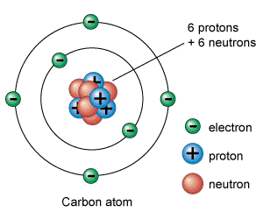
http://ut-images.s3.amazonaws.com/wp-content/uploads/2010/02/c-atom_e.gif

An atom is defined by its atomic number, the number on the periodic table. This indicates how many protons the atom has. Atoms may have more or less neutrons or electrons, but an atom of Carbon ALWAYS has 6 protons. That’s what makes it carbon.

Neutrons have no charge
Protons are positively charged
Electrons are negatively charged

Pure elements have a zero charge, because proton number = electron number. The attraction between the electrons and the protons (plus additional forces) keeps the atom together.

The drawing above is called the Bohr model, after Niels Bohr who developed it. There are other more complex models of atoms, but for routine chemistry, the Bohr model works very well.
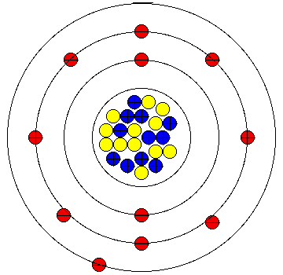

http://www.portlandschools.org/CTS/GrantsProjects/driscc/elements/sodium/sodium.html

This element has 11 protons, 12 neutrons, and 11 electrons.

What is its atomic number?______________________________________

What is it called (use your periodic table)?___________________________________

Using the previous pictures, how would you draw lithium?

What is the atomic number of lithium?_______________________

How many protons does lithium have?_______________________

Lithium has 4 neutrons and 3 electrons. Draw lithium below.

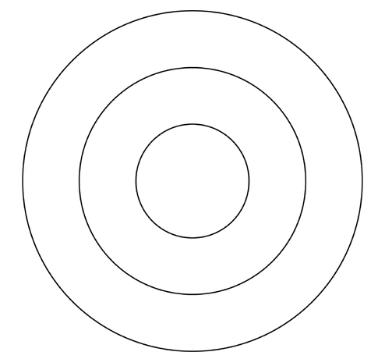

Now we are going to make a Bohr model of lithium using a paper plate, string, and puffballs.
Bohr Model - the Bohr model is an approximation of atomic structure, developed by Neils Bohr. For more information, see: http://chemistry.about.com/od/atomicstructure/a/bohr-model.htm

Supplies:
Paper plate
Puff balls, 3 colors (here I use purple = electrons, green = neutrons, and yellow = protons)
String
Tape
Glue
Scissors

The Bohr model of lithium looks like this:

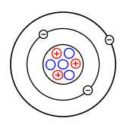
http://www.webanswers.com/science/chemistry/what-is-the-bohr-model-for-lithium-04daed

a paper plate or plates are cut into concentric circles: one small one in the middle, and two in the shape of Os, looking similar to an archer’s target. The small circle is the nucleus and the Os are electron orbitals.
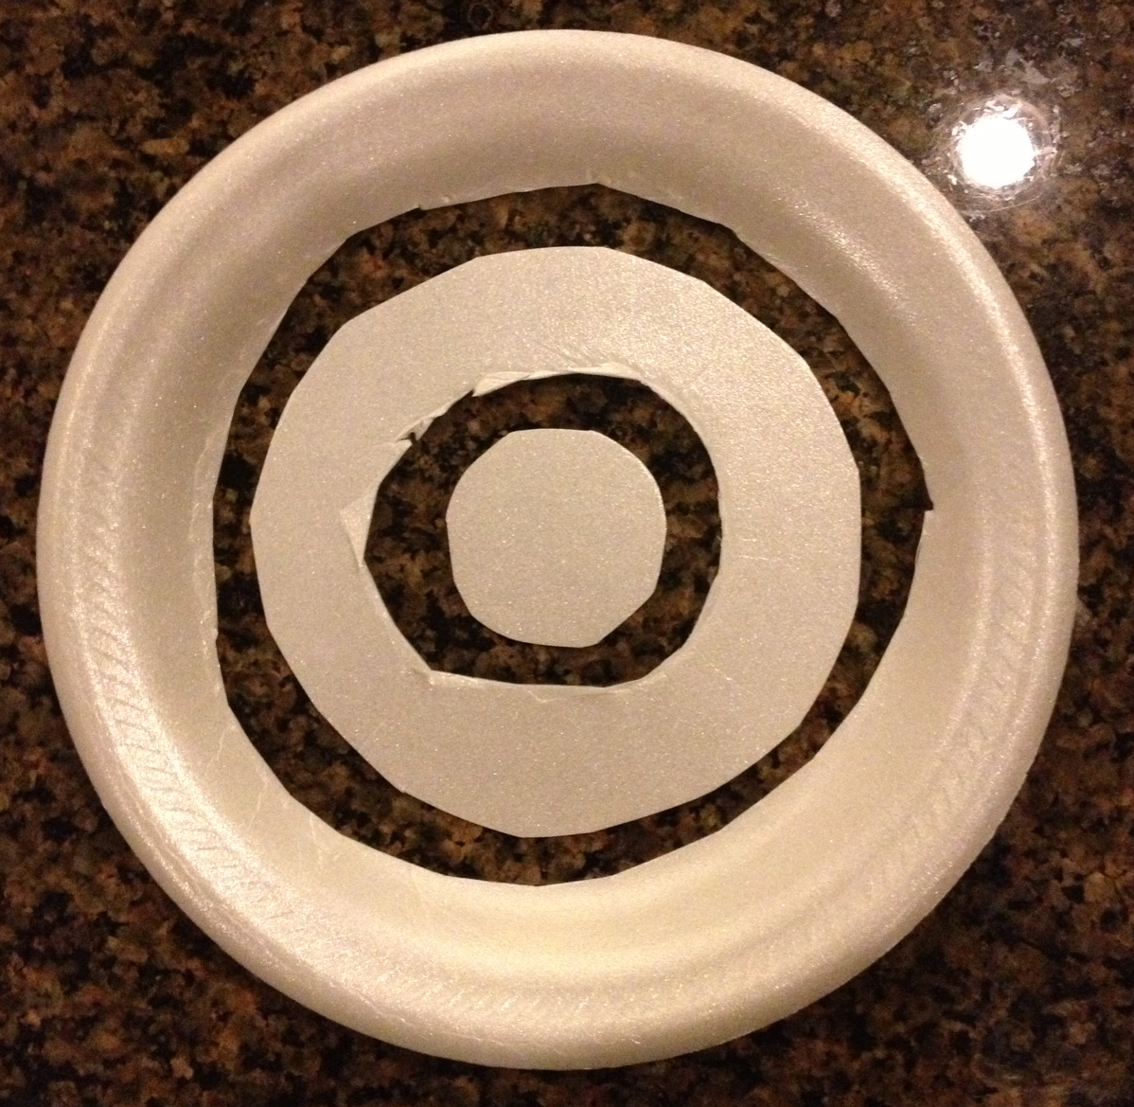Figure 1

Two electrons are glued on the smaller O. One electron is glued on the larger O.

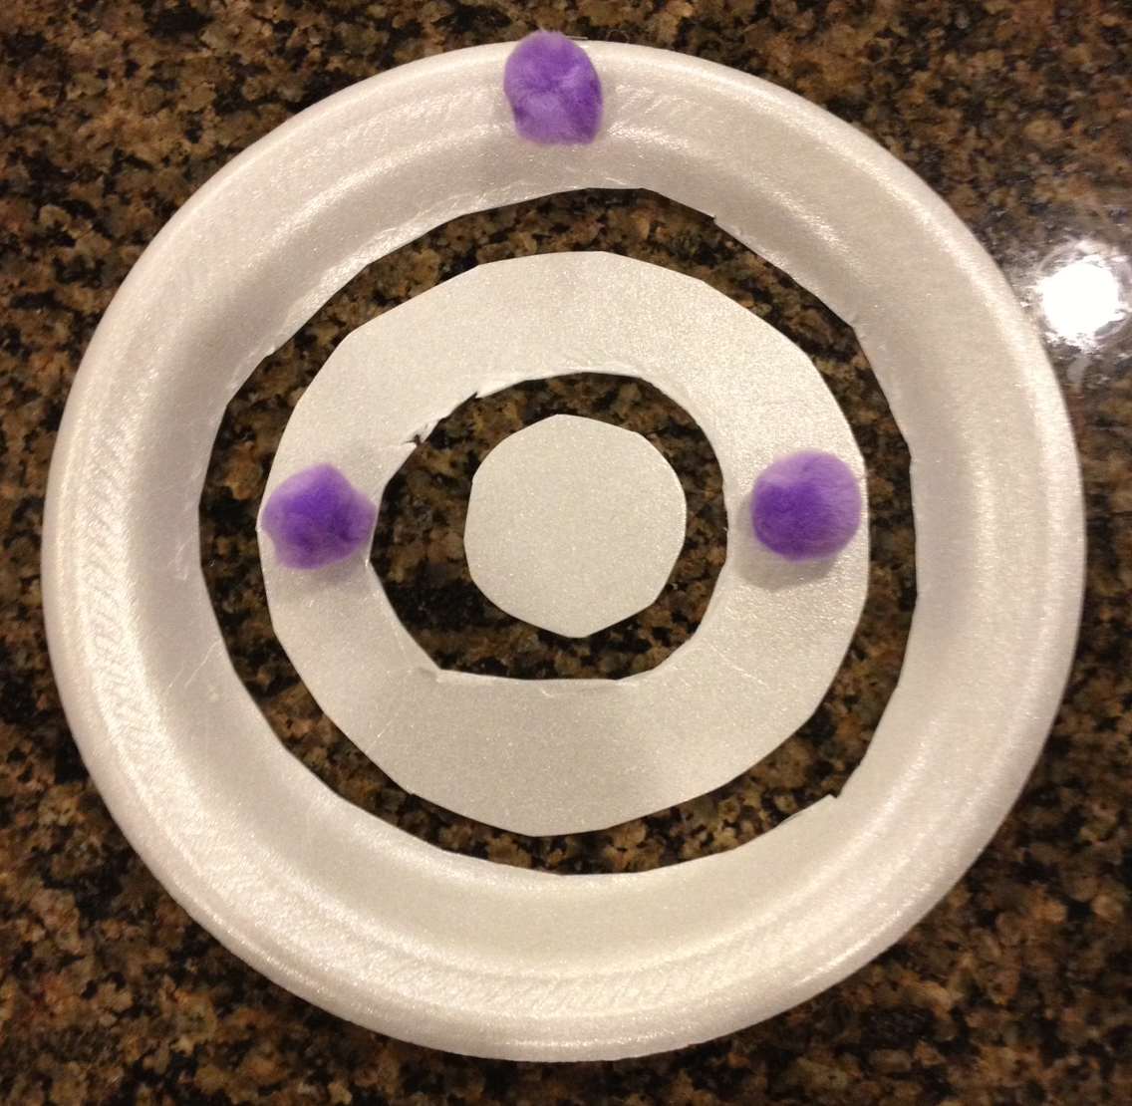 Figure 2

The neutrons and protons are glued on the small inner circle to form a 3D nucleus. Note protons repel, so don’t place them all on the same side if you wish to be realistic.

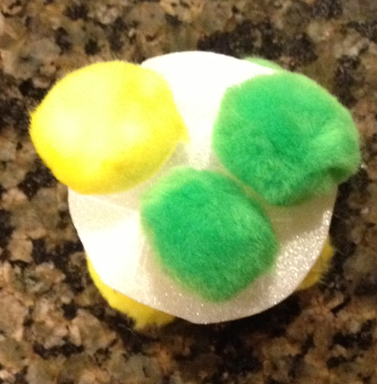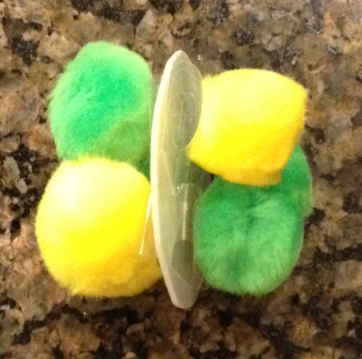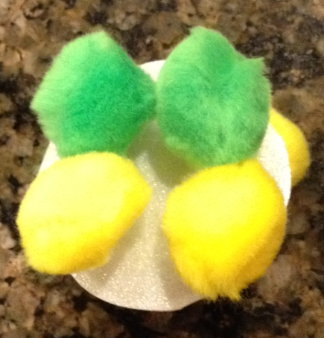
Figure 3

The parts are attached to each other using string, so that the model can turn in a 3D fashion.

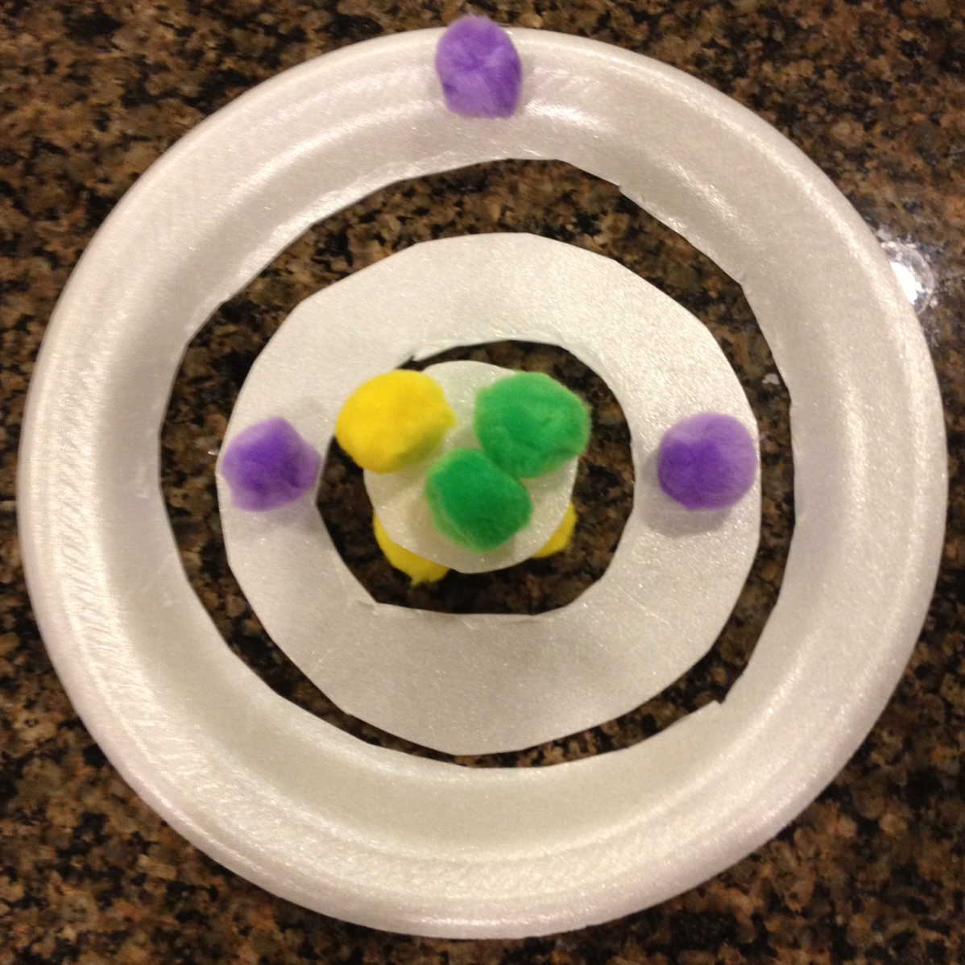

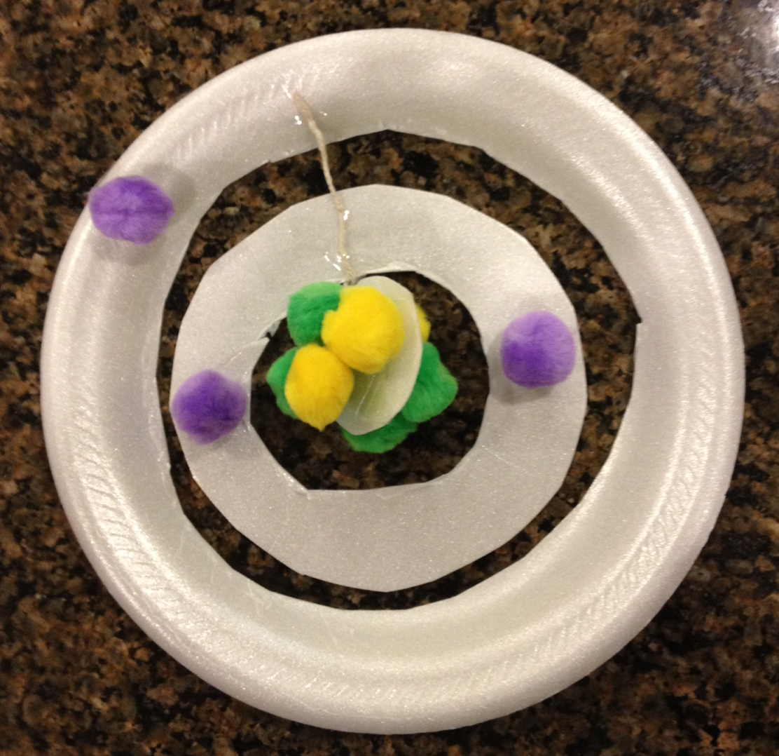 Figure 4
The model is suspended for all to enjoy.

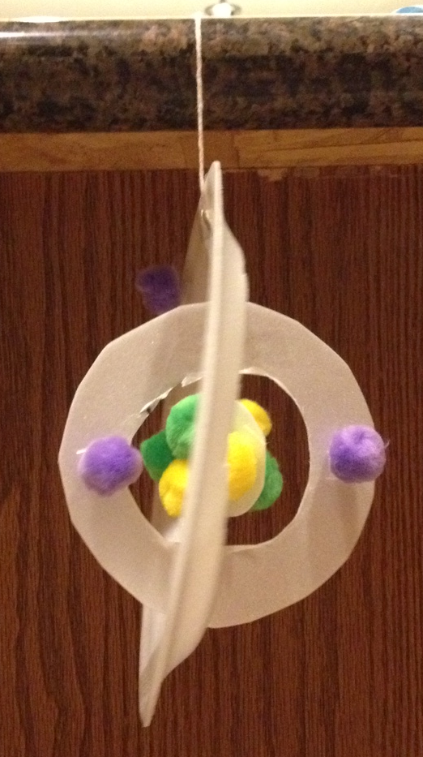

Figure 5

Name____________________________________________________________________

Carbon 14, with 6 protons, 6 electrons, and 8 neutrons.
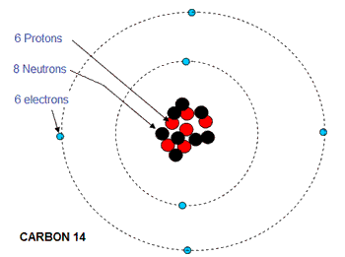
http://www.ejsong.com/mdme/memmods/MEM30007A/classification/Classification.html

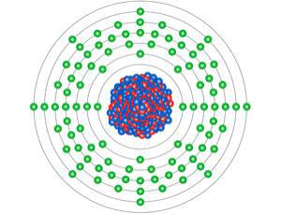
Plutonium, with 94 protons, 94 electrons, and 144 neutrons.
https://physicsforme.wordpress.com/2012/05/17/plutonium-signature-captured-after-50-years-of-trying/

In radioactive elements, like plutonium, the nucleus is unstable because it is too big. Other radioactive elements have too many protons or neutrons. Carbon-14, a radioactive form of carbon, has too may neutrons and its nucleus is unstable. This unstable nucleus will vibrate and contort and attempt to become stable by ejecting particles and giving off energy. This is radioactive decay giving rise to new elements.

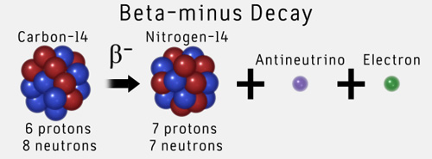

http://www.learner.org/courses/physics/unit/text.html?unit=2&secNum=6

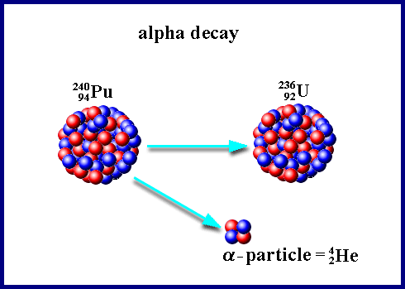
http://www.nuceng.ca/igna/radioactivity.htm

The synthetic elements are radioactive and unstable, so they are made in a lab and are often only seen for a few minutes. For example, element 118 only lives for less than one second before it emits particles and decays.

Making new elements requires colliding known elements at high speed to “add” the protons, neutrons, and electrons together. Below scientists collided two hydrogens to make a helium.

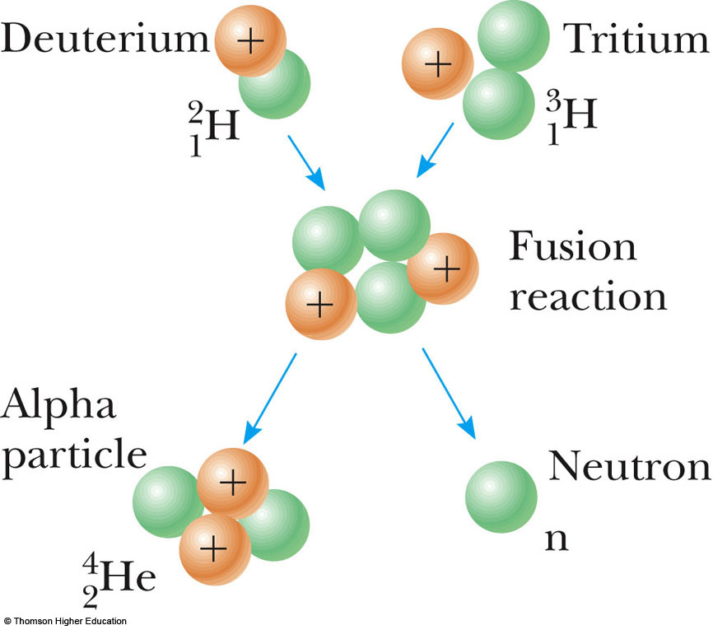
http://goodcleannovels.com/Novels/ColdFusionChapters.html

Element 118 was made by colliding californium plus calcium. Look on your periodic table.

What is the atomic number of californium?________________________

What is the atomic number of calcium?_____________________________

____________________ + ________________________ = 118, or the new element Ununoctium.

